Mr. Henry,

Now that I have my site published to the internet I was able to conduct some coded UI Tests. These tests were also very good in helping me identify weak areas of my code and my site. I realized that in order to perform the UI Tests I had to do it in several steps.

To conduct a UI test is pretty easy once you get the hang of it. From Visual Studio you can create a new Coded UI test project inside your project solution.

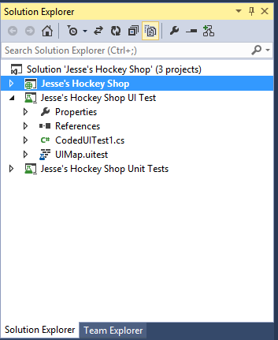

Once you have this you are given a similar architecture to the unit tests that allow you to write methods and call methods that perform actions that were either previously recorded or you can record from scratch.

I had to start from scratch so when conducting my test I used the tool in Visual Studio to record.

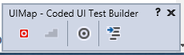

With this tool open you click the red square to begin recording and you must start all the way from actually opening your browser. From here I oened IE and navigated to my site. jesseshockeyshop.azurewebsites.net/

After doing this same process over and over I realized it would be easier to conduct one method that would navigate to the site, then once I was on my site I could simply do the other tests needed, but by calling the one method to start IE and run the site would cut down on a lot of time.

Once I created that method all I had to do was add the following code and everytime it would Open IE, type in jesseshockeyshop.azurewebsites.net and then go to my next steps



From here I had other struggles. I quickly found out that when you want to ASSESS one value to the other you have to stop, create the code, then start a new method in order to ASSESS the values to one another. Also, I could only get the values of the particular control when using IE and it would not work when trying it with Chrome or Firefox.

Finally when I got my first test to run I realized that I was not comparing the values inside the box, but I was comparing the ID’s of each of the controls to each other...this didn’t do me any good so I had to start over and be sure to select the value in the box or control rather than selecting the control itself.

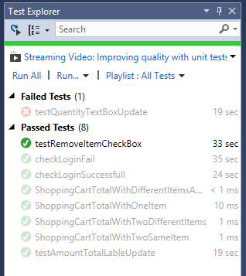

Once I finally got the process down I found the value in having these. I can think of all of the hours of Testing I’ve done for orbitalshift.com and by having a process that could go through click thorugh controls and compare them to what is entered is invaluable.

I also purposely changed some of my code to break in order to test if my tests were working. I made it so my quantity text boxes were not updating when you pressed UPDATE and when I ran my tests they failed as they should.

Overall this section of my Independent Study has been very beneficial and I can’t stress enough the benefit this would provide to a business that is constantly testing their site when new updates go out.

----------------------------------------------------------------

Now that we are in the final week of school I plan on putting the final touches on my site. I want to ensure everything is working by using my newly written tests and also put some final tweaks on the site to make it look aesthetically more pleasing.

Did you hear back from Professor Rob Smith about presenting in his class? Between work and school I need to make sure I can make accommodations for presenting and wanted to make sure I’m on the right track.

Thank you again for your help,

Jesse Fulcher